**Version : 1.01**

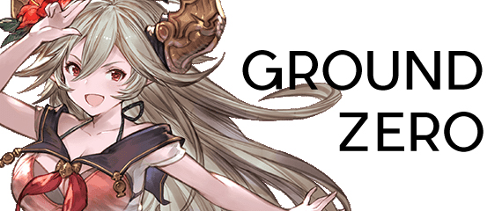

***Note :***App will stop automatically after “Start Button” phase when Captcha appears, AP run out, or problem with your connection.

**Preparation :**

*Currently only for Solo. Will add dual box soon.*

1. For Swordmaster, make sure you have Disparia/Purify Blade/other weapon that have neutral damage skill on it.
2. For non-Swordmaster, you can use Sarasa/Threo or any character with neutral damage skill.
3. Make sure you can 1-hit slime with your neutral damage skill.
4. Finish your daily coop first to avoid unnecessary window.

**How to use :**

1. Set cursor position for specific button/phase. (For details see next page)
2. Press F2 to start.
3. Enjoy!
4. Press F2 again to stop.

**Cursor/Button/Phase Position :**

**MC IMAGE BUTTON**

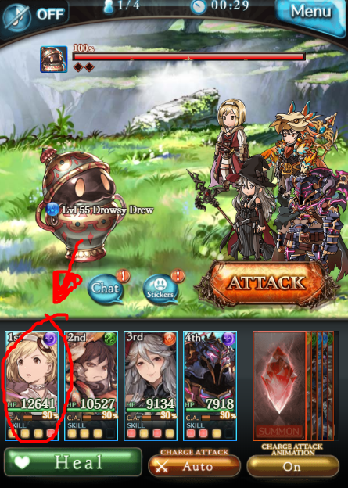

**AP BAR POSITION (IDLE)**

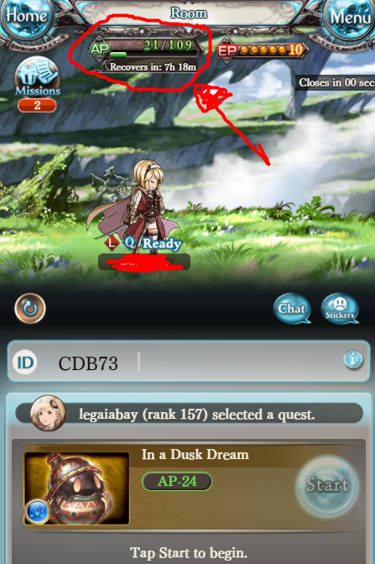

**START BUTTON**

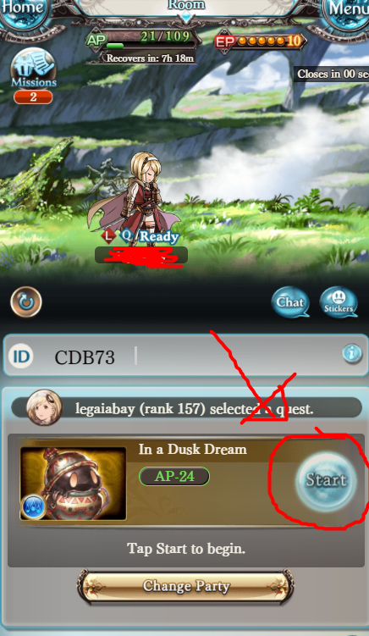

**RESULT “ROOM” BUTTON**

**Note : Refresh (F5) “Quest Result” page to get this empty loot page.**

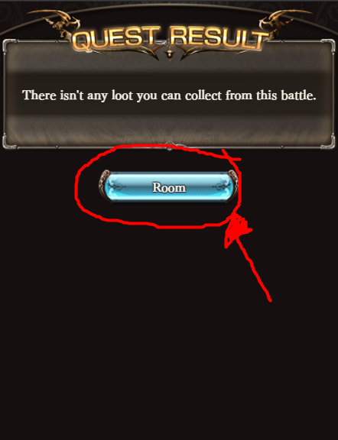

**SKILL 1 BUTTON**

